Past, present, and future in bridge engineering

INTRODUCTION
The following chapter shall introduce the reader to past, present, and future in bridge engineering. The history of engineering is as old as mankind itself, and it is without doubt that technical progress and the rise of human society are deeply interwoven. Bridges have often played an essential role in technical advancement within Civil Engineering.

The development of important types of bridges and the changing use of materials and techniques of construction throughout history will be dealt with in the first part of this chapter. Notably, manifold legends and anecdotes are connected with the bridges of former eras. Studying the history of a bridge from its construction throughout its life will always also reveal a fascinating picture of the particular historical and cultural background.

The second part of this chapter introduces the main challenges that the current generation of bridge engineers and following generations will face. Three important areas of interest are identified. These are improvements in design, construction, maintenance, and rehabilitation of a bridge, application of high-performance materials, and creative structural concepts. As technology advances, many new ways of innovation thus open for the bridge engineer.

1. HISTORY OF BRIDGE CONSTRUCTION
The bridges described in the following sections are examples of their kind. A vast amount of literally thousands of bridges built requires choosing a few exemplary ones to show the main developments in bridge construction throughout the centuries. Any book examining bridges in a historical context will make its own choice, and studying these works can be of great value for understanding of the legacy of bridge engineering. The subdivision into certain periods in time shall provide a framework for the reader’s orientation in the continuous process of history as it unfolds.

1.1 Ancient Structures
It will never be known who built the first actual bridge structure. Our knowledge of past days fades the further we look back into time. We can but assume that man, in his search for food and shelter from the elements and with his given curiosity, began exploring his natural environment. Crossing creeks and crevices with technical means thus was a matter of survival and progress, and bridges belong to the oldest structures ever built. The earliest bridges will have consisted of the natural materials available, namely wood and stone, and simple handmade ropes. In fact, there is only a handful of surviving structures that might even be considered prehistoric, e.g. the so-called Clapper bridges in the southern part of England, as Brown (1993) notes.

1.1.1 Ancient Structural Principles
The earliest cultures already used a variety of structural principles. The simplest form of a bridge, a beam supported at its two ends, may have been the predecessor of any other kind of bridges; perhaps turned into reality through use of a tree that was cut down or some flat stone plates used as lintels. Arches and cantilevers can be constructed of smaller pieces of material, held together by the compressive force of their own gravity or by ropes. These developments made larger spans possible as the superstructure would not have to be transported to the site in one complete piece anymore.

Probably the oldest stone arch bridge can be found crossing the River Meles with a single span at Smyrna in Turkey and dates back to the ninth century BC (Barker and Puckett 1997). Even suspension bridges are no new inventions of modern times but have already been in use for hundreds of years. Early examples are mentioned from many different places, such as India and the Himalaya, China, and from an expedition to Belgian Congo in the early years of this century (Brown 1993). Native tribes in Mexico, Peru, and other parts of South America, as Troitsky (1994) reports, also used them. He also mentions that cantilevering bridges were in use in China and also in ancient Greece as early as 1100 BC. Podolny and Muller (1982) give information on cantilevering bridges in Asia and mention that reports on wooden cantilevers from as early as the fourth century AD have survived.

1.1.2 Trial and Error
In some cases, authors of books or book chapters on the history of bridges use terms such as primitive, probably as opposed to the modern state-of-the-art engineering achievements. It is spoken of a lack of proper understanding, and of empirical methods. From today’s point of view it is easy to come to such a judgement, but one should be careful not to diminish the outstanding achievements of the early builders. In our technical age with a well-developed infrastructure, computer communication, and heavy equipment readily available it is easy to forget about the real circumstances under which these structures were built. Since mathematics and the natural sciences had yet even begun being developed it is not astonishing that no engineering calculations and material testing as adhering to our modern understanding were performed. But a feeling for structures and materials was present in the minds of these ancient master builders. With this and much trial and error they built beautiful structures so solid and well engineered that many have survived the centuries until our days.

1.1.3 The Earliest Beginnings
Earliest cultures to use bridges according to our current knowledge were the Sumarians in Mesopotamia and the Egyptians, who used corbelled stone arches for the vaults of tombs (Brown 1993).

In the fifth century BC the Greek historian Herodotus, who lived from about 490 to 425 BC (Brown 1993), wrote the history of the ancient world. His report on the city of Babylon includes a description of the achievements of Queen Nitocris, who had embankments and a bridge with stone masonry piers and a timber deck built at the River Euphrates. This bridge is believed to have been built in about 780 BC (Troitsky 1994) and was built as described in the following (Greene 1987, p118).

“… and as near as possible to the middle of the city she built a bridge with the stones she had dug, binding the stones together with iron and lead. On this bridge she stretched, each morning, square hewn planks on which the people of Babylon could cross. By night the planks were withdrawn, so that the inhabitants might not keep crossing at night and steal from one another.”

Herodotus’ report does not tell about the construction of this bridge and leaves much room for imagination on how the bridge might actually have looked like. His second report on a bridge, however, gives a more detailed view. A floating pontoon bridge was used by Persian King Xerxes to cross the Hellespont with his large army in the year 480 BC (Brown 1993). Herodotus describes the bridge in detail (Greene 1987, pp482f):

“It is seven stades (a stade was about 660 feet) from Abydos to the land opposite. […] This is how they built the bridge: they set together both penteconters and triremes, three hundred and sixty to bear the bridge on the side nearest the Euxine and three hundred and fourteen for the other bridge, all at an oblique angle to the
Pontus but parallel with the current of the Hellespont. This was done to lighten the strain on the cables. […] When the strait was bridged, they sawed logs of wood, making them equal to the width of the floating raft, and set these logs on the stretched cables, and then, having laid them together alongside, they fastened them together again at the top. Having done this, they strewed brushwood over it, and, having laid the brushwood in order, they carried earth on the top of that; they stamped down the earth and then put up a barrier on either side…”

If one considers Herodotus’ account to be accurate the bridge must have been a fairly impressive structure and without any equivalent at its time. Especially the description of how the pontoons were anchored indicates a well developed understanding of structural principles. Use of bridges for military needs was not uncommon in ancient times. Gaius Iulius Caesar (100 - 44 BC) is amongst the authors who left us very clear records of early bridges. In his De Bello Gallico, written in 51 or 50 BC, he mentions several bridges that he had his troops build during his conquest, e.g. across the Saône, and in the fourth book he describes the famous timber bridge
built across the Rhine in 55 BC. This type of bridge was actually rebuilt a second time later during his conquest. His description of the structure is to such detail that several attempts were made to reconstruct it, and it shows the level of knowledge to which the engineering profession had grown by that time (Wiseman and Wiseman 1990, pp78-80):

“Two piles a foot and a half thick, slightly pointed at their lower ends and of lengths dictated by the varying depth of the river, were fastened together two feet apart. We used tackle to lower these into the river, where they were fixed in the bed and driven home by pile drivers, not vertically, as piles usually are, but obliquely, leaning in the direction on the current. Opposite these, 40 feet lower down the river, two more piles were fixed, joined together in the same way, though this time against the force of the current. These two pairs were then joined by a beam two feet wide, whose ends fitted exactly into the spaces between the two piles of each pair. The pairs were kept apart from each other by means of braces that secured each pile to the end of the beam. So the piles were kept apart, and held fast in the opposite direction, the structure being so strong and the laws of physics such that the greater the force of the current, the more tightly were the timbers held in place. A series of these piles and beams was put in position and connected by lengths of timber set across them, with poles and bundles of sticks laid on top. The structure was strong, but additional piles were driven in obliquely on the downstream side of the bridge; these were joined with the main structure and acted as buttresses to take the force of the current. Other piles too were fixed a little way upstream from the bridge so that if the natives sent down tree trunks or boats to demolish it, these barriers would lessen their impact and prevent the bridge being damaged Ten days after the collection of the timber was begun, the work was completed and the army led across.”

Troitsky (1994) reports on an even older Roman timber bridge, the Pons Sublicius. It is the oldest Roman bridge whose name is known, named after the Latin word for wooden piles. This bridge was built in about 620 BC by King Ancus Marcius and spanned the River Tiber (Adkins and Adkins 1994).

The brief record of timber bridges given in this section would not be complete without mentioning Appolodorus’ bridge across the Danube. It was built in about 104 AD under Emperor Trajan (O’Connor 1993). Its magnitude – the length must have been more than a kilometer – and the unique structure of timber arches makes it special among the Roman bridges of which we have record.

1.1.4 Timber Bridges
Timber bridges and timber superstructures on stone piers will probably have been prevailing in many parts of the Roman Empire at that time. Wood was a cheap construction material and abundantly available on the European continent. Furthermore it can be readily cut to shape and transported with much less effort than stone. The Romans already knew nails as means of connecting timber. Even the principle of wooden trusses was already known, as reliefs on both the Trajan’s Column in Rome (AD 113) and the Column of Marcus Aurelius (AD 193) clearly show truss-type railings of military bridges (O’Connor 1993). However, there is no historic evidence that the Romans actually used the truss as a structural element in their bridges. Truss systems may have actually been used for the wooden falsework that was used for erection of stone masonry arches.

1.1.5 Stone Bridges
Apart from timber bridges, stone masonry arch structures are examples of the outstanding skills of the ancient Romans. The Roman stone arches where built on wooden falsework or centering which could be reused for the next arch once one had been completed. The semicircular spans rested on strong piers on foundations dug deeply into the riverbed. Brown (1993) points out that due to the width of these piers between the solid abutments the overall cross section of the river was reduced, thus increasing the speed of the current. To deal with this problem the Romans built pointed cutwaters at the piers. A very comprehensive study on Roman arches can be found in O’Connor (1993).

The arches used were voussoir arches, which are put together of tapered stones with a keystone that closes the arch. Compressive forces from the dead load and the weight of traffic on the bridge hold the stones together even without use of any mortar. Corbelled arches, on the other hand, consist of stones put on top of each other in a cantilevering manner until they two halves finally meet in the middle. This principle was already known prior to Roman times and was used in vaulted tombs throughout the Old World. Both different arch types are shown in Figure 1-1.

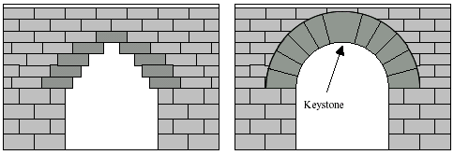

Figure 1-1: Corbelled Arch and Voussoir Arch

1.1.6 Aqueducts and Viaducts
The Roman infrastructure system was very well developed. It served both military and civil uses by providing an extensive network of roads. Aqueducts and viaducts of the Roman era can still be found scattered over the former Roman Empire, primarily in Italy, France, and Spain. Some Roman bridges or their remainders are also located in England, Africa and Asia Minor (O’Connor 1993).

Probably the best-known Roman aqueduct is the Pont du Gard near Nîmes in Southern France, which is shown in Figure 1-2. Built by Marcus Vipsanius Agrippa (64 - 12 BC) in about 19 BC, this structure was part of an aqueduct carrying water over more than 40 km (Liebenberg 1992). The crossing of the River Gard has an impressive height of 47.4 m above the river, consisting of three levels of semicircular arches that support the covered channel on top. The spans of the two lower levels are up to 22.4 m wide. All of its stone masonry was built without use of mortar except for the topmost level. A more recent addition to the Pont du Gard built in 1747 provides a walkway next to the bottom arch level that is an exact copy of the Roman architecture (Leonhardt 1982). Another well-known aqueduct can be found at Segovia in Spain.

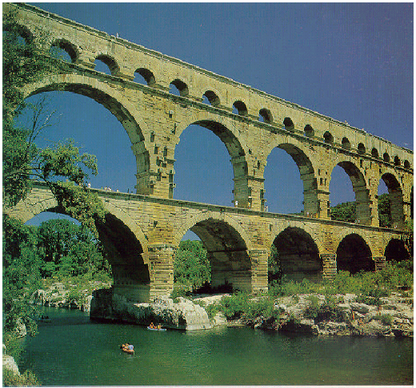

Figure 1-2: The Pont du Gard, Nîmes, France (taken from Brown 1993, p18)

Sextus Iulius Frontius (c. 35 - 104 AD) wrote De Aquis Urbis Romae on the history and technology of the Roman aqueducts (O’Connor 1993). Aqueducts were used to provide thermae, baths, and public fountains with water; few residential buildings had an own connection. However though, the amount of water available for every citizen is estimated to have equaled or even exceeded today’s standards for water supply systems. Adkins and Adkins (1994) speak of half a million to a million cubic meters of water that were provided through Rome’s aqueducts per day.

Located in Spain is a bridge that attracts interest because of its scale and the magnificent setting. The Puente de Alcántara crosses the River Tagus at Caceres close to the border to Portugal with six elegant masonry arches as shown in Figure 1-3. Again, these arches were built without the use of mortar. The name of the bridge contains some redundancy, since it is derived from an old Arabic term for ‘bridge’. The two main arches with a gate on the roadway are higher than the Pont du Gard and remain the longest Roman arches, both spanning 30 m (Brown 1993). The name of the Roman engineer who built this masterpiece in 98 AD under Emperor Trajan is known. Caius Iulius Lacer’s tomb is found nearby, and the gate with the famous inscription Pontem perpetui mansuram in saecula mundi (I leave a bridge forever in the centuries of the world) has survived the centuries (Gies 1963, p16).

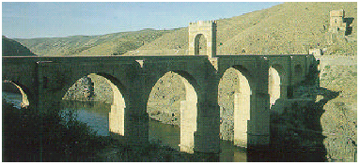

Figure 1-3: The Puente de Alcántara, Caceres, Spain (taken from Brown 1993, p25)

Even earlier dates the Pons Augustus or Ponte d’Augusto in Rimini, Italy. It was begun under Emperor Augustus and finished in 20 AD under Emperor Tiberius (O’Connor 1993) and is considered one of the most beautiful Roman bridges known. Five solid spans of only medium lengths between 8 and 10.6 m are decorated in an extraordinary way, with niches framed by pilasters over each pier (Steinman and Watson 1941). Andrea Palladio, architect of the Renaissance, used this bridge to develop his own bridges, and thus spread the fame of this bridge across Europe, as Gies (1963) writes.

Rome itself still houses ancient bridges built during the Roman era. Brown (1993) gives information that eight major masonry bridges are known of in Rome, of which six still exist at the River Tiber. They are the Ponte Rotto or Pons Aemilius, of which only a single span remains, initially built in the second century BC, the Ponte Mollo (or Milvio) or Pons Mulvius, built 110 BC; and the Ponte dei Quattro Capi or Pons Fabricius, built 62 BC. The Ponte Cestius was built 43 BC and altered under subsequent emperors. Considered to be the most beautiful of Rome’s bridges is the Pons Aelius (now known as Ponte Sant’Angelo), built AD 134 under Emperor Hadrian. Giovanni Lorenzo Bernini (1598 - 1680) modified it in 1668 by adding statues of angels and a cast iron railing. The Ponte Sant’Angelo is shown in Figure 1-4. The Ponte Sisto, the youngest bridge of this ensemble, was built in AD 370.

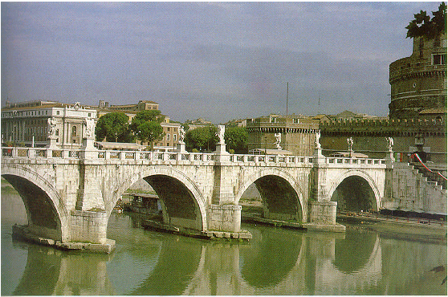

Figure 1-4: The Ponte Sant’Angelo, Rome, Italy (taken from Leonhardt 1984, p69)

1.1.7 Religious Symbolism
An interesting fact in the context of early bridge building is religious symbolism. Higher positions in Roman hierarchy often involved both spiritual and practical tasks, such as control of the markets and storage facilities, or the building activities. O’Connor (1993, p2) tells that bridge building supervision “was placed in the care of the high priest, who received the title pontifex, commonly translated as ‘bridge builder’, from the Latin pons (bridge) and facere (to make or build).” This title, pontifex maximus, was passed on to later Roman emperors and through early Christian bishops even to the present Pope. In this context O’Connor (1993, p3) offers the explanation that this important title symbolized the “bridge from God to man…”

1.1.8 Vitruvius’ De Architectura
The famous Roman architect and engineer Marcus Vitruvius Pollio (Morgan 1960) does not specifically mention bridges in his work De Architectura (The Ten Books on Architecture), which was written in the first century BC. However, aqueducts are the topic of a whole chapter in Book Eight, and cofferdams, important for erecting bridge piers in riverbeds, are described in detail in a section on harbors, breakwaters, and shipyards. According to him, a double enclosing was constructed of wooden stakes with ties between them, into which clays was placed and compacted. Afterwards, the water within the cofferdam was removed (several different engines to pump water, such as water wheels and mills, and the water screw are described by him), and work on the pier foundations could begin. In case the soil was to soft Vitruvius advised to stake the soil with piles.

Another fact of particular interest for today’s engineers is the description of concrete that Vitruvius gives. In a comprehensive list of construction materials the origin and use of pozzolana is described, a volcanic material that performs a cementitious reaction if mixed as a powder with lime, rubble, and water. This reaction is hydraulic; i.e. the concrete obtained, called opus caementitium, can harden even under water. Together with use of brick masonry and natural stone, as well as with timber and sand, the Romans had an enormous range of flexibility in constructing their buildings and structures. A truly unique example of their skills is the Pantheon in Rome, built under Emperor Hadrian around the year AD 125. It is topped with a majestic 43.2-m wide dome made of ring layers of concrete (Harries 1995). Use of lighter aggregates towards the top, stress-relieving masonry rings, regular voids on the inside and tapering of the dome to reduce its weight provide the structural stability that has made the Pantheon withstand all influences until the present day.

1.1.9 Contributions of Ancient Bridge Building
In conclusion, the main bridge construction principles were already known and used to some extent in ancient times. Due to lack of surviving timber structures one can only rely on historical reports and depictions of these. Prevailing structures in ancient times were the semicircular stone arch bridges, many of which have survived until the present day. Roman builders left a legacy of impressive structures in all parts of former Roman Empire. Arch structures were intelligently used both for heavy traffic and elaborate water supply systems; temporary timber structures also served military purposes. These systems were developed to the full extent that was technically possible and were not to be surpassed in mastery until many centuries later.

Engineering knowledge was already documented systematically by authors such as Vitruvius, whose work influenced the builders of later centuries considerably. Great builders and artists, such as Bramante, Michelangelo, and Palladio were careful students of his works.

1.2 The Middle Ages
For the historical overview given in this study, the term Middle Ages refers to the period of time between the fifth and the late fifteenth century; other authors may set somewhat different limits, e.g. the eleventh to the sixteenth century (Troitsky 1994). Thus, spanning a time of about a thousand years in one section of this study can necessarily not cover all bridges built, but give a representative selection of the achievements that were made. Their significance and history will be discussed further in this section.

1.2.1 Preservation of Roman Knowledge
After more than 1,200 years of existence, the once mighty Roman Empire finally fell apart around the fifth century AD (Adkins and Adkins 1994), and a period of anarchy and chaos began. Invasions of the Eternal City destroyed much of the former grandeur. The major achievements of the Roman civilization began to be forgotten, and their cities were deserted. Bridges as large and solid as the Roman bridges were to be built again only centuries later. Gies (1963) reports that the predominant community structures in Europe of the eighth and ninth century were small feudal agricultural states. The knowledge of Roman culture was kept in monasteries scattered across the old continent. Ancient authors, such as Vitruvius, were copied by hand many times by the monks who thus preserved these treasures for future generations.

1.2.2 Bridges in the Middle East and Asia
At about the same time another rise of bridge building began. Had the Romans themselves vanished in Europe, their influence on the Middle East and even Asia began to prosper. Persian rulers built pointed brick arches, and the coming blossom of bridge building reached as far as China, as Gies (1963) reports. The Chinese skillfully built elegant segmental stone arches with roadways that followed the swinging shape of the arch, and they also built cantilevers of timber on stone piers. According to Gies (1963) examples were reported by the thirteenth century Venetian explorer Marco Polo (c. 1254 - 1324), who traveled Asia for several decades and contributed much to the European view of the world. Indian cultures undertook own bridge building under this influence and further developed the suspension bridges.

1.2.3 Revival of European Bridge Building
Finally, the art of bridge building also began to blossom in Europe again. Most authors particularly mention the importance of the church in the Middle Ages that contributed to this development. Contacts with the Middle East were made during the crusades, when the pilgrims and knights saw evidence of the skills of Arabian cultures.

Importance of the church in these times cannot be exaggerated, since in many cases the order that in society existed was enforced primarily by clergymen who held court, regulated merchants’ fairs, and kept the monasteries as centers of knowledge and spiritual experience. It has already been mentioned in Section 1.1.7 how the ancient title pontifex maximus of the Roman high priest became to be used by the Popes.

The church had considerable influence on all major medieval building undertakings. The biggest of these structures, the awe-inspiring cathedrals and large stone bridges, would not have been built otherwise. Working on them was considered to be pious work (Gies 1963) and was thus a very honorable task to be performed. Some religious orders formed to bring progress to hospices and to build bridges for the travelers’ sake (Steinman and Watson 1941). Spreading from Italy, where the Fratres Pontifices originated from, similar brotherhoods also formed in other countries, e.g. France (Frères Pontiffes) and England (Brothers of the Bridge).

1.2.4 Construction and History of Old London Bridge
Probably the most colorful and vivid history, unsurpassed by any other, is related to a bridge located in a city that gained an enormous growth in the medieval times (Gies 1963, p47). London had been founded by the Romans, who called it Londinium. Little is known about the centuries after the Romans had left and about former bridges in London, although there is arguments for an early timber structure that crossed the Thames in AD 993 (Gies 1963).

Peter of Colechurch, a monk from a nearby district of the city, was the builder of Old London Bridge, which was built between 1176 and 1209. He was never to see his bridge finished, since he died in 1205 and was buried in the chapel that he had built on the bridge. As can be seen in Figure 1-5, Old London Bridge altogether consisted of nineteen pointed masonry arches on crude piers with large cutwaters, none of them equal in shape. A drawbridge was also included in the structure. Piles were rammed into the soft bed of the river on which the piers rested. The bridge must have seemed very massive and inelegant to an observer, and its appearance would change even further with later centuries. Fortifications on the bridge, namely the two towering gates were added. It became customs to display the heads of executed prisoners on top of this gate, and after building a new tower for a decayed one, it was thereafter called Traitor’s Gate (Gies 1963).

As the length of Old London Bridge was only about 300 m the massive piers of Old London Bridge took away more than half of the width of the river so that the speed of the current increased tremendously. Boats with passengers were said to be “shooting the bridge” when they passed under it, and records of numerous accidents have been reported (Gies 1963, p40).

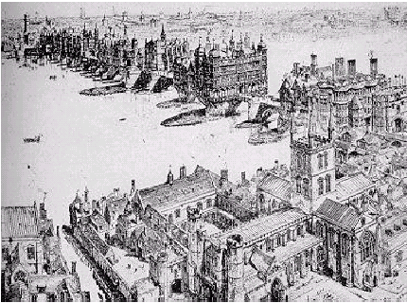

Figure 1-5: Old London Bridge, London, Great Britain (taken from Steinman and Watson 1941, p69)

Located in the heart of London, Old London Bridge served the city for more than six hundred years, and for most of this time, about five and a half centuries, it remained the only solid passing of the Thames. In 1740 finally, Westminster Bridge was built, and in 1831 building a new bridge at the old location was begun.

Over all this long time Old London Bridge continuously changed its appearance. Apart from the chapel already mentioned, more buildings were added on top of the superstructure. Except for a few openings where the river could actually be seen from the roadway, the bridge in its later days carried literally dozens of houses. These were crammed at both sides of the roadway, leaving only relatively little space in the middle. Wooden frames held the houses together over the roadway, and some reportedly even had basements under the arch spans, leaving even less room for boats to pass. Even wheels were erected under several spans to power watermills. Merchandising flourished on the bridge and tolls were collected for passing it. The ease of water supply and wastewater removal at the bridge made it a favorite place for the trades of the Londoners, Gies (1963) lines out.

Many anecdotes and legends are attached to Old London Bridge. It even once happened that a complete house fell off the bridge into the Thames. As Steinman and Watson (1941, p64) put it, the “life story of this six-hundred-year-old bridge would fill many a good-sized volume and would include exciting accounts of fire, tournaments, battles, fairs, royal processions, dramas, songs, and dances.” A highly readable description of these centuries full of history is given in a chapter by Gies (1963).

1.2.5 The Pont d’Avignon
As with Old London Bridge the bridge over the Rhône at Avignon has a legendary history. It is not exactly known who the builder was; some sources mention the name of Brother Bénoît as the builder, who began work on the bridge in 1178. The legend, however, is related to the vision of a local shepherd named Bénèzet, after which the Bishop of Avignon had the bridge built. In comparison with Old London Bridge, though built almost at the same time, the Pont d’Avignon was much more elegant. It bridged the 900-m long distance with twenty or twenty-one elliptical arches of which only four remain with spans up to 35 m, longer than any Roman arches. All other spans were destroyed in wars and through ice on the river. The Pont d’Avignon was built in merely ten years (Brown 1993). A new arch shape, the so-called three-centered arch was used for the spans, which composed of two segments of a circle that are connected with a smaller curved segment at their top.

In accuracy of the stone masonry and with its majestic elegance the Pont d’Avignon was the first bridge in Europe that could achieve and surpass the Roman level of engineering. The remaining arches carry a small chapel at which the roadway of the bridge narrows down to only 2 m for defense purposes. Bénèzet died prior to completion in 1184 and was buried in the chapel.

1.2.6 Further Notable Medieval Bridges
Several other medieval bridges are worth being mentioned in this overview of medieval bridge building. The Pont Valentré at Cahors in France, shown in Figure 1-6, is about 150 years younger than the Pont d’Avignon. It resembles its older brother with its pointed slender arches and the triangular cutwaters, but has been preserved completely. Six regular arches of 16.5 m span length and three watchtowers at its ends and in its middle (Brown 1993) give the bridge over the Lot a graceful appearance.

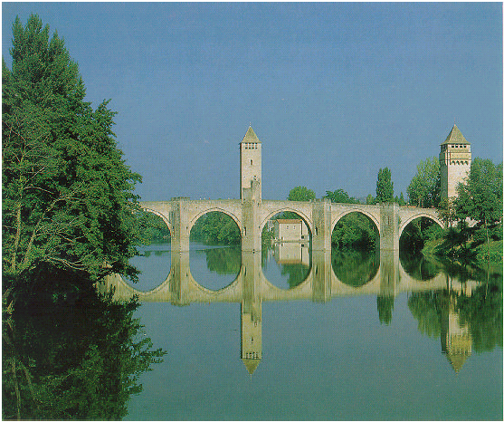

Figure 1-6: The Pont Valentré, Cahors, France (taken from Brown 1993, p29)

A multiuse bridge from 1345 that was built by Taddeo Gaddi (c. 1300 - 1366) can be found in the old merchants’ city of Florence in Italy. Although it then had a relatively small in population from today’s point of view, Florence was an important center for trades of all kinds. It also was home to the famous Medici, a family clan that had gained enormous wealth and influence through banking and commerce since the thirteenth century. Later, they also supported the fine arts and thus contributed to Florence becoming a major cultural center of Europe of the Renaissance. Today, unlike any other city, Florence houses buildings from the Renaissance times. The Ponte Vecchio crosses the River Arno with three shallow arch spans, of which the middle span reaches 30 m length. Figure 1-7 shows this truly unique bridge. In this bridge for the first time segmental arches were used. The segmental arch consists of an arch with less than a semicircular curvature, thus having a much smaller rise. Later the bridge was extended and turned into a covered bridge by building shops at both sides of the roadway and a gallery above these that connects the Uffizi and Pitti Palaces (Brown 1993). The shops are still in use by goldsmiths today.

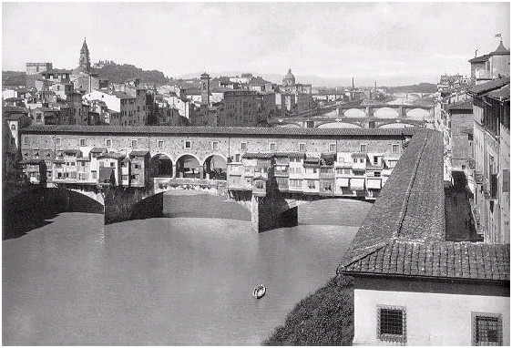

Figure 1-7: The Ponte Vecchio, Florence, Italy (taken from Leonhardt 1984, p75)

Steinman and Watson (1941) report of covered medieval timber bridges that have been preserved until today, especially a pair of bridges in Lucerne, Switzerland. Both bridges, the Kapellbrücke and the Spreuerbrücke, are crossing the River Reuss and were part of the medieval city’s fortifications. The Kapellbrücke with the so-called Wasserturm (watertower) is said to date from 1333 (Steinman and Watson 1941) and has its name from a nearby chapel of St. Peter. It is shown in Figure 1-8. Paintings under the roof show scenes from the local history. Similar in shape, the Spreuerbrücke was completed in 1408. It features a large amount of pictures under its wooden roof that depict a Dance of Death, painted in the seventeenth century, as Gies (1963) reports.

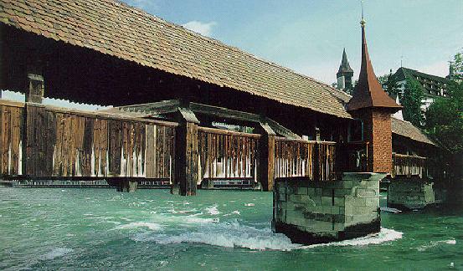

Figure 1-8: The Kapellbrücke, Lucerne, Switzerland (taken from Brown 1993, p76)

The last bridge to be mentioned in this account is in itself a link between different historical eras. The Charles Bridge (Karluv Most) in Prague in the Czech Republic was built after a flood in 1342 had destroyed a previous structure across the River Vltava. Emperor Charles IV had the new bridge begun in 1357 under the leadership of Peter Parlér. Its total length of almost 520 m was achieved by building sixteen arches with a maximum span of 23.4 m. The bridge is not exactly straight, but has two slight curves in its longitudinal axis, probably because the builder thus utilized more favorable ground conditions for the pier foundations. A mixture of styles can be found in the bridge; the arches are still Roman in their almost semicircular shape, whereas the solid triangular cutwaters are clearly medieval (Brown 1983). Two decorated towers are found at the bridge with one of them dating back to the twelfth century, being renovated in 1590 in the Renaissance style. Especially the thirty Baroque statues of Saints on the parapets, mostly of stone, have made the bridge famous. Construction was mainly finished by the end of the fourteenth century, although some reports point out a period of one and a half centuries (Brown 1993). However, the many changes and additions of later times contributed to the unique appearance of the bridge, which is a symbol of the city of Prague itself.

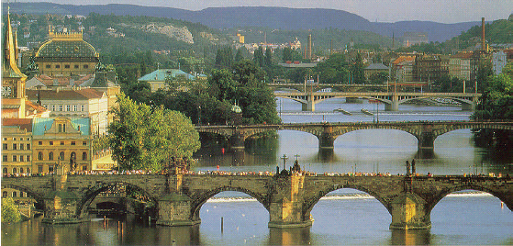

Figure 1-9: The Charles Bridge, Prague, Czech Republic (taken from Brown 1993, p32)

1.2.7 Purpose of Medieval Bridges
A very important characterization of medieval bridge building and their decorations is given by Steinman and Watson (1941), who lay out that medieval bridges served the following purposes:
They served military, spiritual, and even commercial and residential functions. Thus, medieval bridges were the first example of real multipurpose bridges and were indeed closely linked with the lives of their contemporaries. This multi-purpose concept later reappears in the twentieth century as an expectation for the future of bridge utilization and is discussed in Section 2.3.3.4.

1.2.8 Contributions of Medieval Bridge Building
During medieval times bridge construction was revived in the Old World with considerable influence of the church. Construction was based on empirical knowledge of materials and structural behavior. The level of mastery and accuracy that the Roman engineers had set in their stone masonry was hardly reached again until the coming era that had just began to dawn. Sometimes the bridges were even built with rubble and a brick veneer, as Steinman and Watson (1941) point out. They also note that building solid foundations for the massive piers was a problem, as especially the mortar employed was not made of the durable hydraulic cement that the Romans had used, but normal lime mortar. Span lengths rarely surpassed Roman achievements.

Development was made, however, in the shape of arches. Formerly only semicircular arches with a height of half their diameter had been used in Europe. Now pointed and even flat segmental arches offered much flexibility for span-to-rise ratios. An advantage of pointed arches was that they put less load on the falsework, which makes their construction easier (Troitsky 1994). Even some multi-centered elliptical arches were constructed, as e.g. in the Pont d’Avignon.

In conclusion it can be stated that although the bridges of the Middle Ages are impressive in their history, few real engineering developments were made in the art of bridge construction, except for more varied shapes of the arches, especially in longer multi-span river crossings.

1.3 The Renaissance
Had the church and its focus on the spiritual world strongly influenced people of the medieval times, the Renaissance brought along a change in thinking. Renaissance literally translated means rebirth, in a classical sense. The Renaissance times put “emphasis on this life, not on that of the hereafter” (Steinman and Watson 1941, p71). The importance of learning and the accumulation of knowledge grew again after the first European universities had been formed as early as the thirteenth century. Along with this new mentality went commercial growth, more traffic, and naturally also the need for more and better roads and bridges. Arts explored new areas and the natural sciences were prospering in their development. Multi-talented personalities performed their work during those times. Steinman and Watson (1941) specifically name Leonardo da Vinci, Filippo Brunelleschi, Michelangelo Buonarroti, Georgius Agricola, Nicholas Copernicus,
Galileo Galilei, and Francis Bacon, not to forget William Shakespeare, Johannes Kepler, Tycho Brahe, Blaise Pascal, Christiaan Huygens, Isaac Newton, Robert Hooke, and others. It is this colorful and creative mixture that makes the Renaissance a very interesting era in the development of humanity.

1.3.1 Renaissance Trusses
During the Renaissance, the truss system was developed further for use in bridge construction. Known since Roman times, the truss now was finally seen as a means of superstructure in itself. Every truss relies on the geometrical principle that the very shape of a triangle cannot be changed without disrupting the length of any of its sides. Gies (1963, p100) puts this in a clear sentence, “a triangle cannot be distorted.” Structures constructed of triangles – or, in modern times, of their spatial equivalent, the tetrahedron – thus are very strong. Regardless of the stiffness of its hinges the truss is resistant to forces imposed. Many special truss configurations developed later in building covered bridges in America (see Section 1.4.6), carrying the names of their developers, and there is virtually no limit to the possibilities of the truss principle.

1.3.2 Palladio’s I Quattro Libri dell’Architettura
Andrea Palladio (1508 - 1580), born in Padua as Andrea di Pietro dalla Gondola, described several different trusses in his I Quattro Libri dell’Architettura (The Four Books of Architecture) (Palladio 1570), also mentioning an arched truss. An example of his designs is shown in Figure 1-10.

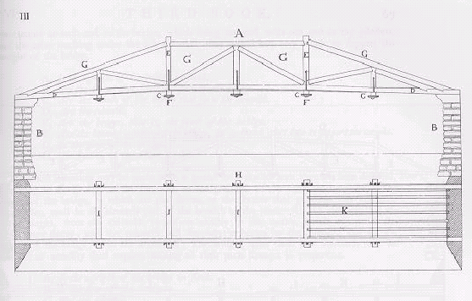

Figure 1-10: Palladian Truss (taken from Palladio 1570, p66)

He made use of the so-called king post truss, which consisted of a triangle that had a vertical member resting on the lower chord, the king post (Gies 1963). These designs for the most part were not used in practice until much later, as his ideas still were very advanced for his times. Palladio, according to Steinman and Watson (1941) was strongly influenced by Vitruvius, whose De Architectura he translated. Palladio revived the classical architectural orders that Vitruvius had described and wrote extensively about materials and geometrical proportioning, private and public buildings, and about roads and ancient and modern bridges. Truss structures had already been used extensively in building construction, specifically for roof trusses, and it is astonishing that no major bridges of the truss system where built earlier.

1.3.3 Veranzio’s Machinae Novae
Brown (1993) mentions the ideas of another outstanding architect and engineer, Fausto Veranzio (or Faustus Verantius, 1551 - 1617), who published his Machinae Novae (Veranzio 1615) in about 1615. Interesting about this work is both the technical contents, and the way of publication. Veranzio compiled a comprehensive volume of existing and theoretical mechanical engines, mostly watermills, windmills, clocks, a parachute – similar to da Vinci’s (1452 - 1519) design – and some agricultural tools. Most important, however, are the depictions and descriptions of bridges that appeared. A very simple truss, wooden arch bridges, and even a masonry arch with prestressing rods are included. Modern looking suspension bridges made of ropes or iron eyebars are further presented in considerable detail.

Two editions of Machinae Novae are known, one of which contains the copperplate engravings and the text in Latin and Italian, another edition additionally contains the text in old-fashioned Spanish, French and German. Several other books of mechanical engines were published in about this time. The afterword of Veranzio’s facsimile edition mentions a number of other authors.

1.3.4 The Rialto Bridge
Similar in concept to the Ponte Vecchio, but completely different in its appearance is the Rialto Bridge in Venice, Italy, over the Canale Grande, built 1587 - 1591 when a previous bridge over the Grand Canal was to be replaced because of obsolescence. Venice by this time was a flourishing merchants’ and seafarers’ city. Over several decades a variety of proposals were submitted to the Venetian Senate, including a design by Palladio until the final design by Antonio da Ponte (1512 - 1597) was chosen. A single 27-m long segmental arch spans the waters with a 6.4 m rise and the considerable width of 22.9 m (Brown 1993). The Rialto Bridge is shown in Figure 1-11.

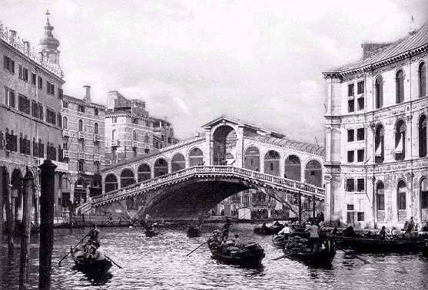

Figure 1-11: The Rialto Bridge, Venice, Italy (taken from Leonhardt 1984, p96)

Most difficult to construct were the foundations, which required stepped groups of piles to be rammed into the soft ground close to existing buildings, onto which masonry layers were placed. A mechanical pile hammer was used (Steinman and Watson 1941) to drive the piles to refusal. Doubts as to the stability of the foundations arose in public and interrupted the construction process. Finally construction was resumed after an investigation by the Venetian Senate decided in favor of da Ponte and his work. Major falsework was erected to build the single span. The courses of stones in most of the superstructure were laid in voussoir-like fashion radial to the centerpoint of the arch, giving the arch an enormous stability. Shortly after completion the bridge really proved to be stable when it withstood an earthquake without any damages. Two rows of small shops at both sides of the bridge with a center roof above give the bridge its typical unique appearance (Brown 1993, pp36f).

1.3.5 French Renaissance Bridge Building
France became an important location in bridge building in the Renaissance. King Louis XIV had the so-called Corps des Ponts and Chaussées established in 1716 in order to promote the building and maintenance of the national road system. Derived from the success of this group the École des Ponts et Chaussées was founded and became the first real engineering school worldwide. An experienced engineer, Jean-Rodolphe Perronet (1708 - 1794) took the lead of this institution. Brown (1993) also provides background information on Perronet’s most important discovery. When noticing that an arch of a bridge under construction was leaning to the still-tobe-built span Perronet realized that the arches mutually exerted horizontal thrust. This principle he used for the Pont de Neuilly, built 1771 to 1772 across the Seine north of Paris with five elliptical 36.6-m spans. The arches he constructed were extraordinarily shallow and rested on very slender piers of only 4 m width, with strong abutments resisting the thrust from the arches. Perronet also experimented with horse-driven piles (Gies 1963). Furthermore, the Pont de Neuilly incorporated a relatively new shape of the arches themselves – a tapered edge of the arches called corne de vache created a shadow that underlined the arches and made their front view appear even shallower, as can be see in Figure 1-12. This corne de vache, or splayed arch (Steinman and Watson 1941), had been used for the first time in another stone arch erected in Paris, the Pont Notre Dame, built by the priest Fra Giovanni Giocondo between 1500 and 1507 (Gies 1963). This special design, according to Gies (1963) also facilitates a broader deck and funnels the passage of floodwaters through the arch.

Figure 1-12: The Pont de Neuilly, Paris, France (taken from Brown 1993, p42)

However, the new construction scheme of shallow segmental arches required that the arches were erected on falsework simultaneously. Previous constructions had mostly utilized very solid piers that carried an arch even when its neighbors had not been completed yet. In this case, construction of the superstructure was done during one year only, which employed a large work crew. Perronet used sophisticated means to construct the foundations. The bucket wheels to dewater the cofferdams were powered by the current of the river itself (Brown 1993). Despite the elaborate manner of construction and the reduced weight of the long-spanning bridge, there were still some settlements of the piers. The Pont de Neuilly remained in service until 1956, when it was removed.

Perronet built several other bridges. His final works, the Pont de la Concorde in Paris, built 1787 to 1791, remains an example of extraordinary engineering achievement. Its five arches with slightly increasing span lengths towards the middle arch bridge the Seine are shown in Figure 1-13. The parapet of this bridge is not massive, as usually built until then, but an open balustrade that gives the bridge further lightness (Leonhardt 1984).

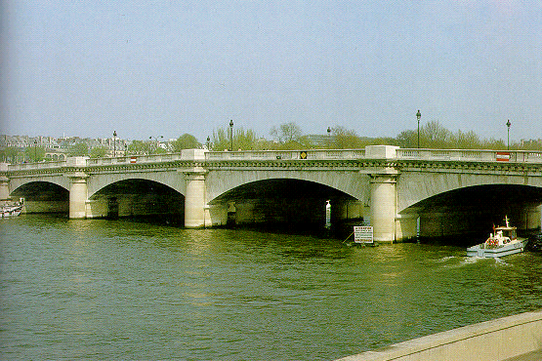

Figure 1-13: The Pont de la Concorde, Paris, France (taken from Leonhardt 1984, p83)

Another well-known bridge of the same era shall not remain unmentioned at this point, as it is a very beautiful structure of harmonic proportions, shown in Figure 1-14. The Pont Neuf, which literally means “New Bridge”, is located at one end of the Seine Island and was built between 1578 and 1607. Leonhardt (1984) notes the unusual width of 20.8 m, which also incorporated the corne de vache principle. The Seine Island divides the bridge into two parts, a longer northern half with seven arches, and a southern half with five skewed arches. The pier width is only 4.5 m.
Cofferdams were employed, but regarding the foundations Steinman and Watson (1941) report that initially no pile foundation was built to withstand the scour of the river current, making repair work necessary.

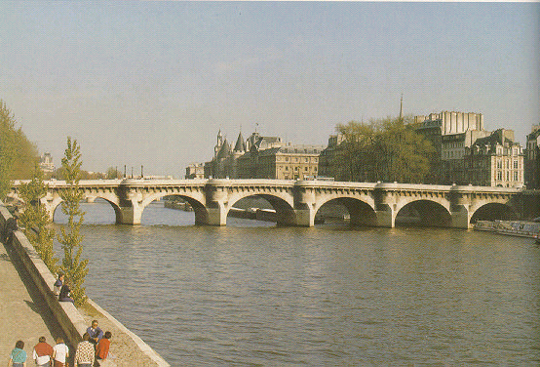

Figure 1-14: The Pont Neuf, Paris, France (taken from Leonhardt 1984, p92)

1.3.6 English Renaissance Bridge Building
After Old London Bridge had served the British capital for about 550 years, finally plans for a new bridge were made. Westminster Bridge was built between 1740 and 1747, carrying out a thirteen-span version with semicircular arches and pronounced piers. As the foundations were the most difficult part of the works, the Westminster Bridge Commission asked the builder, Charles Labelye, to first only build the foundations until further notice (Brown 1993). Labelye was a graduate of the École des Ponts et Chaussées that was mentioned in Section 1.3.5 (Gies 1963).

Brown further reports that Labelye efficiently used a timber caisson, whose base remained under layers of masonry whereas the sides could be detached and reused. Père Romain, who was consulted by the designer Jules-Hardouin Mansart in building the Pont Royal in Paris, had first used the caisson technique in 1685 (Gies 1963). Labelye furthermore employed horse-driven pile driving machines that were far more effective than manually driven machines. But even with these sophisticated techniques foundation of bridges remained difficult, for some considerable settlement in one of the piers of Westminster Bridge required extensive repair work around the pier.

1.3.7 Contributions of Renaissance Bridge Building
The Renaissance times brought more daring bridge structures with them. The piers of the bridges became more slender as the span-to-rise ratios of the bridges became larger. Had the ratio formerly mostly been very small, the Renaissance bridges brought along a considerable increase in span-to-rise ratios. Most importantly, the bridge builders used elliptical arches, as the three centered arch, and very shallow segmental arches to their full extent.

Although there were still some problems with foundations of the piers, a variety of methods, e.g. using pile driving machines and cofferdams as well as the first caissons had been used in practice and builders were confident in these methods. The need to follow suitable ground conditions in the riverbed diminished, so that more flexibility in location of bridges and their piers grew.

The bridges naturally had to withstand the same environmental influences, but they were mastered in different ways now. Longer slender spans with fewer piers diminished the problem of scour at the foundations considerably, and the builders also experimented with cutwater shapes different from the triangular medieval type, i.e. more rounded forms as for the Pont de la Concorde. Tapered edges, called corne de vache, could better lead the waters through the bridge in case of floods. Piers were not built extremely solid anymore to withstand the construction loads from an unfinished arch and to withstand the pressures exerted by floodwaters and ice on the river. Segmental arches were shallower than semicircular arches. However though, their abutments needed to be strong to withstand the horizontal forces that arose from these arches. It has already been mentioned that segmental arches required considerable work efforts to erect all spans at the same time.

Summarizing, the Renaissance did not only change the appearance of bridges, but also successfully experimented with new principles in bridge construction, thus giving later builders a bigger variety of choice how to build their bridges at hand. A new revolution was still to come that did not arise from varying stone arches anymore, but that opened new horizons through introduction of a new material into bridge construction – iron.

